Supplementary Appendix
1.1. Ensuring Cross Year Comparability
We run a separate factor analysis for each year of available data. We run a separate factor analysis for each survey year because the set of questions changes from survey to survey. The key issue with this approach is ensuring that results of the analyses are comparable across years. This is a common issue in studies that examine change over time. Poole and Rosenthal’s DW-NOMINATE common-space measure of legislator ideology confronts this same issue—the set of votes is different in every Congress therefore making comparisons about legislators across years is difficult. Poole and Rosenthal deal with this problem by using legislators that are common to multiple sessions of Congress as a bridge set which allows the authors to assess year-to-year changes in legislator ideology. The authors evaluate change in legislator ideology by assuming each legislator’s position remains fixed across sessions. Therefore, change across years can be measured relative to the fixed (by assumption) position of these common legislators. Change can only be measured relative to some constant, therefore we must hold something fixed in order to evaluate change. Fortunately we are not forced to adopt the assumption that survey respondents retain fixed positions from year to year. This is because can we utilize questions that are common to every election as a benchmark to evaluate year-to-year change, which is the equivalent of legislators voting on the same piece of legislation in every year.
There are several questions that have been asked in every administration of the ANES survey since 1972. We utilize one question that loads very highly on the first dimension as a common benchmark to evaluate the year-to-year consistency of the factor loadings in order to ensure that the ideological dimensions are comparable across years. The question that consistently loads the highest on the first dimension is “what role should the government play in ensuring everyone has a good standard of living.” We fix the dimensionality of the space by rotating the entire factor-loading matrix through this common question—the first dimension runs though this question as closely possible in every year. This means that the dimensions that define the policy space are the same in every year and direct comparisons between the years. These comparisons are possible because we are now utilizing the same metric to evaluate changes. We present the set of factor loadings for each year in Table A1. Table A1 demonstrates that questions that are common to multiple years load consistently across time, suggesting that the underlying ideological dimensions remain constant from election to election.
1.2 Measuring Political Sophistication

There is a considerable amount of research that demonstrates that an individual’s attentiveness and receptiveness to elite cues varies as a function of political sophistication (Zaller 1992; Layman and Carsey 2002; Layman et al. 2010). Individuals must be aware of and able to understand the significance of elite cues (of which an increase in polarization is one of many potential examples) in order to respond to them. One of the potential threats to our inferences is that not all individuals are responding to changes on the elite level, rather, or findings are being driven by only a small and politically engaged subset of the population. In order to test this possibility, we must first construct a measure of an individual’s level of political sophistication.
We utilize an additional battery of ANES questions to build a scale of political sophistication. Our basic approach follows that of Goren (2013). We build an additive scale that that combines questions that gauge an individual’s level of correct political knowledge (e.g. do they know the majority party in the House and/or Senate?) with questions gauging a respondent’s ability to think in abstract terms (e.g. are they able to place the Republican Party to the right of the Democratic Party on an ideological scale) in addition to the interviewer’s assessment of the respondent’s level of political sophistication. The more correct answers an individual provides, the higher their score on the sophistication scale. We then break down the electorate into high, medium, and low sophistication subsamples (defined as the top, middle, and bottom third of respondents on the sophistication scale) and then assess whether the relationships policy principles, polarization, and expressed attitudes and behaviors holds across all levels of sophistication or whether our findings are being driven by a specific subset of the electorate?

1.3 The Consistency of Factor Loadings Across Varying Levels of Political Sophistication

There is a considerable amount of evidence that politically sophisticated citizens exhibit a greater degree of ideological constraint compared to less sophisticated citizens (Converse 1964; Zaller 1992). Stated differently, sophisticated citizens are more likely to see the connections between various policy issues and less likely to give contradictory answers within a particular policy domain (e.g. favors both cutting taxes and increasing spending on services). The likelihood that politically sophisticated voters exhibit a greater degree of ideological constraint poses a potential issue for our factor analysis models, since these models assess the degree of correlation between policy items. The issue here is whether it is appropriate to apply this measurement model across all levels of political sophistication? It is possible that high sophistication citizens are driving the results of our factor analysis models and these same policy dimensions fail to hold among low sophistication citizens.
We assess this possibility by rerunning our factor analysis models on high, medium, and low sophistication subsamples of respondents. We perform this analysis across three separate years, 1980, 1992, and 2008. The goal of this analysis is to assess whether we can uncover the same policy dimensions consistently across all three sophistication subsamples. The results of these analyses are displayed in Table A2. The results of these factor analyses on the sophistication subsamples suggest that the same policy dimensions structure the political orientations of high, medium, and low sophistication citizens. Generally speaking, the factor loadings are the highest among the high sophistication subsample. This finding is not terribly surprising, as it is reasonable to expect high information respondents to more readily connect individual domains with the underlying policy dimension. Yet, the patterns of inter-correlations between the policy items are similar across all three sophistication subsamples in all three years. These findings corroborate other dimensional analyses that divide the electorate by level of sophistication (e.g. Goren 2004) and suggest that it is appropriate to utilize a pooled factor analysis model in our analysis due to the fact that the same underlying dimensions share a similar structure across all three sophistication groups.
1.4 The Moderating Effect of Political Sophistication on the Relationship Between Elite-Level Polarization and Mass-Level Responses

In the study of public opinion, political sophistication is often considered an important explanatory variable. The politically sophisticated are better able to grasp abstract political concepts, adopt ideologically consistent positions, and evaluate which party or candidate best matches their own policy orientations. The relationship between political sophistication and political behaviors raises two questions for our analysis: First, does an individual’s propensity to translate policy orientations into attitudes and behaviors vary according to their level of political sophistication? Second, is an individual’s response to changes in elite polarization conditioned by their level of political sophistication?
We begin by addressing this first question. Tables A3 through A6 replicate analyses in Table 1 (in the main text) for low, medium, and high sophistication subsamples of ANES respondents. What are the conclusions that we draw from these analyses? One basic conclusion that we can draw is that an individual’s policy orientations significantly shape their political attitudes and behaviors across all levels of sophistication. There are some important caveats, however. While the relationship generally holds across all sophistication groups, the link between policy orientations and political attitudes and behaviors is strongest amongst high sophistication respondents. The economic dimension is generally significant for all sophistication levels, but the magnitude of the coefficients tends to be larger for high sophistication groups, and also appears to increase over time. We also find that the second dimension score tends to become statistically significant for all groups over time, but statistical significance tends to kick in earlier for high sophistication groups as compared to low. Like the economic dimension, we also find that the coefficients on the social dimension tend to be substantively larger for high sophistication groups. The exception to this generalization is the relationship between policy principles and self-reported ideology among low sophistication respondents. We do not find much evidence that suggests low sophistication respondents’ ideological self-labels are influenced by their underlying policy orientations. This is perhaps unsurprising, since this is the most abstract of the four dependent variables that we analyze. Medium and high sophistication respondents’ ideological self-labels are strongly shaped by their policy orientations.
So do the results of these analyses run counter to the sophistication-interaction hypothesis that is prevalent in the literature? We view these findings as offering support for this hypothesized interaction—high information respondents are most strongly guided by their policy orientations, but even low information voters attitudes and behaviors are still significantly guided by meaningful policy orientations. We touch more on this in our next point.
Tables A7 through A10 replicate Table 2 (in the main text) for low, medium, and high sophistication subsamples of ANES respondents. Tables A3-A6 demonstrated that high sophistication respondents’ attitudes and behaviors were more strongly guided by their policy orientations than low or medium sophistication respondents. In these analyses we assess whether an individual’s level of political sophistication conditions their response to changes in the level of elite polarization. Interestingly, it seems that respondents of levels of political sophistication adopt more polarized attitudes and behaviors in response to increases in polarization on the elite-level. Figures A1 through A4 display the marginal effects of an increase in elite-level polarization by level of political sophistication and across all four outcomes of interest. We generally find that an increase in polarization is associated with a significant change in individual level behavior across all of the other subsamples. This interaction is significant across a range of modifying values on both the economic and social dimension in the majority of subsamples. The main exceptions to these findings are for low sophistication respondents in the ideological self-labeling, models. We also find largely null results for the second dimension policy orientation variable when examining low information voters in the party ID and vote choice models, specifically. There are fewer indications of differences between groups when we focus on the economic dimension (excepting the aforementioned ideology models).
Overall, the results of this latter set of models are more mixed than the results of the previous set of models, but we generally find that increasing elite polarization affects the behavior and attitudes of voters at all sophistication levels. This is clearest for the economic dimension in the second set of models. Alternatively, the evidence from the previous set of models suggests that politically sophisticated individuals’ political attitudes and behaviors are more strongly shaped by their policy principles relative to low sophistication individuals. Thus, we are left with decidedly mixed evidence regarding the sophistication-interaction hypothesis.
1.5. Establishing Causality with Coincident Trends—Robustness Test
We ran additional robustness checks to evaluate our results when using the change in polarization instead of the level variable. In Table 4 of the main document we include interactions between the individual-level policy orientation variables and a linear time trend variable (see Table 4). Here we replicate the models from Table 4 using a slightly different specification to further demonstrate the robustness of our findings. Table A11 replicates Table 4 from the main text with the exception that we do not include interaction terms between individuals’ policy orientations and the linear time trend. We omit these interactions because there is no clear theoretical reason as to why we include them in the model, other than to control for some unspecified temporal process (i.e., something other than elite polarization) that may be affecting mass level behaviors. We also want to be sure that the results from Table 4 hold up under a slightly less demanding model specification—including several additional interaction terms puts considerable computational strain on the models. So while the results from Table 4 generally support our primary findings, the errors increase markedly in many models as compared to the original estimates. Therefore, we present the alternative specification here, where we control for a linear time trend but do not interact this time trend with individual level economic and social orientations.
We plot the marginal effects from the models in Table A11 in Figures A5 and A6. These figures can be compared to Figures 5 and 6 (respectively) in the primary manuscript. As Figures A5 and A6 show, the results of these models are largely consistent with our primary model specifications. Generally speaking, the marginal effect of the change in polarization continues to match our primary findings displayed in Table 4 of the main text. The primary difference is the marginal effects displayed in the appendix figures A5 and A6 feature tighter confidence intervals than their counterparts in the main text. However, the substantive conclusions that can be drawn from these analyses remain similar. It does not appear that the inclusion of these interaction terms is leading us to reach dramatically different conclusions about the relationship between elite polarization, mass-level behavior, and any unspecified temporal processes.

Table A1: Factor Loadings Across Common Questions 1972-2008
 | 1972 | 1976 | 1980 | 1984 | 1988 | 1992 | 1996 | 2000 | 2004 | 2008 | 2012
Economic Dimension
Government Insurance | .45 | .38 | ~~ | .44 | .50 | .45 | .45 | .36 | .47 | .47 | .61
Government S.L. | .61 | .52 | .67 | .60 | .65 | .59 | .67 | .53 | .64 | .71 | .71
Aid to Blacks | .67 | .72 | .69 | .5 | .63 | .5 | .61 | .53 | .62 | .62 | .61
Social Dimension
Abortion | .53 | .52 | .66 | .58 | .59 | .62 | .62 | .62 | .64 | .65 | .61
Women’s Role | .44 | .60 | .51 | .45 | .48 | .52 | .48 | .58 | .48 | .49 | ~~
Authority of the Bible | ~~ | ~~ | .66 | .69 | .55 | .62 | .64 | .58 | .66 | .61 | .80

Table A2: Factor Loadings by Sophistication Tertile for Years 1980, 1996, and 2008
Factor Loadings 1980
 | Low Sophistication |  | Medium Sophistication |  | High Sophistication
 | Econ | Soc | Econ | Soc | Econ | Soc
Government S.L. | 0.621 | 0 | 0.614 | 0 | 0.7238 | 0
School Prayer | 0.1939 | -0.4723 | -0.0991 | -0.669 | -0.2605 | -0.781
E.R.A. | -0.0127 | 0.4153 | 0.198 | 0.3613 | 0.385 | 0.3886
Aid to Blacks | 0.6976 | 0.2227 | 0.5194 | 0.2013 | 0.7536 | 0.0688
Fed Gov. too Strong | 0.425 | 0.0542 | 0.2927 | 0.0419 | 0.5495 | -0.02
Bussing | 0.6346 | 0.121 | 0.5312 | 0.2038 | 0.6763 | 0.2348
Urban Unrest | 0.5369 | 0.1792 | 0.5047 | 0.268 | 0.6015 | 0.2659
Fed Gov. Wasteful | 0.36 | 0.0606 | 0.5098 | 0.0408 | 0.4254 | 0.0559
Bible Scale | 0.1471 | -0.5956 | 0.1522 | -0.6669 | -0.0379 | -0.7015
Women’s’ Role | 0.146 | 0.5585 | 0.0181 | 0.4391 | 0.2832 | 0.4752
Abortion | -0.1358 | 0.5483 | -0.285 | 0.7015 | 0.0264 | 0.6282

Factor Loadings 1996

 | Low Sophistication |  | Medium Sophistication |  | High Sophistication
 | Econ | Soc | Econ | Soc | Econ | Soc
Government Ins. | 0.2416 | 0.1012 | 0.4476 | 0.1053 | 0.6474 | 0.0751
Government S.L. | 0.5635 | 0 | 0.6235 | 0 | 0.7778 | 0
Fed Gov. Too Strong | 0.2945 | 0.3292 | 0.2448 | 0.1907 | 0.1919 | 0.1699
S.S. Spending | 0.2811 | -0.2642 | 0.4568 | -0.1182 | 0.4128 | -0.206
Fair jobs for Blacks | 0.6475 | 0.0225 | 0.6578 | 0.1044 | 0.8011 | 0.2905
Welfare | 0.4659 | -0.1905 | 0.7197 | -0.079 | 0.7217 | 0.1192
Aid to poor | 0.6502 | -0.2088 | 0.6933 | -0.0138 | 0.7294 | -0.081
Aid to Blacks | 0.5191 | 0.0981 | 0.6951 | 0.08 | 0.7717 | 0.0258
Immigrants | 0.3165 | 0.0473 | 0.2555 | 0.0425 | 0.1445 | 0.1667
School Funding | 0.3493 | 0.0921 | 0.453 | 0.148 | 0.5158 | 0.0789
Foreign Aid | 0.332 | -0.3105 | 0.2696 | -0.0652 | 0.2416 | 0.1222
Gay Military | 0.2557 | 0.4603 | 0.2831 | 0.4983 | 0.5275 | 0.4402
Gay Discrimination | 0.4875 | 0.4581 | 0.417 | 0.4935 | 0.6258 | 0.4148
Traditional Values | 0.082 | -0.2318 | 0.1468 | 0.615 | 0.3158 | 0.7108
New Lifestyles | -0.0591 | -0.1392 | -0.1472 | -0.6038 | -0.3795 | -0.6179
Bible Scale | 0.1772 | -0.5717 | -0.0003 | -0.6023 | -0.2356 | -0.6353
Women’s Role | 0.221 | 0.2968 | 0.165 | 0.4198 | 0.4163 | 0.5441
Abortion | -0.0503 | 0.4132 | -0.0247 | 0.7133 | 0.3056 | 0.6391

Factor Loadings 2008

 | Low Sophistication |  | Medium Sophistication |  | High Sophistication
 | Econ | Soc | Econ | Econ | Econ | Soc
Government Ins. | 0.2138 | 0.2784 | 0.2649 | 0.1555 | 0.664 | 0.0484
Government S.L. | 0.528 | 0 | 0.6045 | 0 | 0.7959 | 0
More/Less Gov. | 0.1665 | 0.1869 | 0.5359 | 0.0674 | 0.7272 | 0.0247
S.S. Spending | 0.1783 | 0.1991 | 0.3561 | 0.0647 | 0.4808 | -0.1192
Fair jobs for blacks | 0.7964 | 0.2773 | 0.6935 | 0.2188 | 0.6356 | 0.1392
Welfare | 0.5648 | 0.1007 | 0.6291 | 0.2546 | 0.6855 | 0.0046
Aid to poor | 0.6177 | 0.2701 | 0.6381 | 0.1871 | 0.7875 | -0.0294
Aid to Blacks | 0.7024 | 0.1373 | 0.6775 | 0.1217 | 0.6764 | 0.1303
Immigrants | 0.3264 | 0.1311 | 0.1386 | 0.219 | 0.2003 | 0.2615
School Funding | 0.2329 | 0.3359 | 0.3595 | 0.3184 | 0.6344 | 0.1107
Enviro. Spending | 0.3906 | 0.1525 | 0.4798 | 0.2853 | 0.6306 | 0.1066
Foreign Aid | 0.3923 | 0.0119 | 0.4726 | 0.1097 | 0.4968 | -0.0378
Gay Adoption | -0.1123 | 0.642 | 0.0695 | 0.7744 | 0.3381 | 0.8489
Gay Military | 0.0409 | 0.601 | 0.0499 | 0.5661 | 0.2775 | 0.5278
Gay Discrimination | -0.0085 | 0.5384 | -0.0052 | 0.5406 | 0.353 | 0.635
Traditional Values | -0.0322 | 0.3293 | 0.1072 | 0.5648 | 0.3684 | 0.6376
New Lifestyles | 0.1574 | -0.2652 | -0.0364 | -0.5692 | -0.3686 | -0.5705
Bible Scale | 0.2347 | -0.3917 | 0.2247 | -0.6011 | -0.1869 | -0.6263
Women’s Role | 0.0205 | 0.5878 | -0.092 | 0.2965 | 0.1878 | 0.362
Abortion | -0.1909 | 0.5366 | -0.1332 | 0.3462 | 0.3429 | 0.6767

Table A3: Party ID by Voter Sophistication
 | 1972 | 1976 | 1980 | 1984 | 1988 | 1992 | 1996 | 2000 | 2004 | 2008 | 2012
Party ID -- All Sophistication Levels
Economic | 0.487*** | 0.428*** | 0.775*** | 0.952*** | 0.947*** | 0.965*** | 1.177*** | 0.953*** | 1.102*** | 1.101*** | 1.201***
 | (0.058) | (0.043) | (0.052) | (0.048) | (0.047) | (0.040) | (0.039) | (0.047) | (0.048) | (0.037) | (0.033)
Social | -0.189** | 0.012 | 0.020 | 0.067 | 0.169*** | 0.048 | 0.272*** | 0.405*** | 0.360*** | 0.286*** | 0.233***
 | (0.059) | (0.046) | (0.056) | (0.052) | (0.050) | (0.042) | (0.046) | (0.048) | (0.057) | (0.040) | (0.036)
Observations | 1080 | 1697 | 997 | 1201 | 1311 | 1892 | 1355 | 1213 | 966 | 1733 | 1822
R-squared | 0.060 | 0.047 | 0.150 | 0.210 | 0.210 | 0.230 | 0.325 | 0.254 | 0.311 | 0.302 | 0.371
Party ID -- Low Sophistication
Economic | 0.226* | 0.169* | 0.401*** | 0.438*** | 0.436*** | 0.603*** | 0.654*** | 0.514*** | 0.716*** | 0.663*** | 0.823***
 | (0.103) | (0.075) | (0.116) | (0.103) | (0.096) | (0.086) | (0.106) | (0.107) | (0.137) | (0.094) | (0.081)
Social | -0.170 | 0.043 | -0.094 | -0.029 | -0.197 | -0.112 | -0.066 | 0.056 | 0.144 | 0.052 | 0.061
 | (0.106) | (0.073) | (0.130) | (0.104) | (0.110) | (0.079) | (0.104) | (0.100) | (0.121) | (0.079) | (0.069)
Observations | 374 | 572 | 221 | 266 | 329 | 550 | 379 | 335 | 280 | 516 | 606
R-squared | 0.018 | 0.009 | 0.055 | 0.057 | 0.063 | 0.084 | 0.100 | 0.071 | 0.094 | 0.095 | 0.148
Party ID -- Medium Sophistication
Economic | 0.288** | 0.298*** | 0.578*** | 0.804*** | 0.775*** | 0.813*** | 1.087*** | 0.979*** | 0.903*** | 1.002*** | 1.177***
 | (0.106) | (0.076) | (0.090) | (0.109) | (0.088) | (0.079) | (0.076) | (0.086) | (0.091) | (0.075) | (0.057)
Social | -0.005 | 0.065 | -0.143 | -0.191 | 0.071 | 0.038 | 0.243** | 0.378*** | 0.338** | 0.252*** | 0.241***
 | (0.100) | (0.086) | (0.112) | (0.110) | (0.088) | (0.081) | (0.084) | (0.084) | (0.111) | (0.072) | (0.063)
Observations | 382 | 499 | 312 | 396 | 487 | 602 | 452 | 418 | 332 | 575 | 642
R-squared | 0.020 | 0.028 | 0.090 | 0.120 | 0.123 | 0.158 | 0.258 | 0.217 | 0.201 | 0.213 | 0.337
Party ID -- High Sophistication
Economic | 0.895*** | 0.727*** | 0.997*** | 1.212*** | 1.171*** | 1.127*** | 1.255*** | 1.021*** | 1.251*** | 1.177*** | 1.351***
 | (0.088) | (0.068) | (0.075) | (0.063) | (0.069) | (0.060) | (0.058) | (0.074) | (0.069) | (0.053) | (0.054)
Social | -0.295** | 0.079 | 0.195* | 0.227** | 0.412*** | 0.194** | 0.483*** | 0.602*** | 0.532*** | 0.466*** | 0.308***
 | (0.113) | (0.083) | (0.080) | (0.074) | (0.070) | (0.068) | (0.073) | (0.075) | (0.090) | (0.063) | (0.063)
Observations | 324 | 626 | 464 | 539 | 495 | 740 | 524 | 460 | 354 | 642 | 574
R-squared | 0.209 | 0.131 | 0.256 | 0.365 | 0.397 | 0.358 | 0.473 | 0.388 | 0.519 | 0.440 | 0.532

Table A4: Voter Ideology by Voter Sophistication
 | 1972 | 1976 | 1980 | 1984 | 1988 | 1992 | 1996 | 2000 | 2004 | 2008 | 2012
Ideology -- All Sophistication Levels
Economic | 0.522*** | 0.426*** | 0.570*** | 0.576*** | 0.561*** | 0.462*** | 0.646*** | 0.543*** | 0.731*** | 0.606*** | 0.688***
 | (0.046) | (0.035) | (0.050) | (0.041) | (0.040) | (0.034) | (0.033) | (0.056) | (0.038) | (0.035) | (0.032)
Social | 0.215*** | 0.381*** | 0.429*** | 0.281*** | 0.383*** | 0.390*** | 0.487*** | 0.657*** | 0.524*** | 0.594*** | 0.456***
 | (0.045) | (0.036) | (0.045) | (0.039) | (0.037) | (0.035) | (0.033) | (0.056) | (0.043) | (0.036) | (0.033)
Observations | 770 | 1280 | 701 | 987 | 1052 | 1459 | 1110 | 453 | 778 | 1283 | 1304
R-squared | 0.225 | 0.210 | 0.275 | 0.215 | 0.255 | 0.241 | 0.378 | 0.391 | 0.426 | 0.306 | 0.343
Ideology -- Low Sophistication
Economic | 0.168 | 0.109 | -0.349 | 0.042 | -0.013 | -0.153 | 0.010 | 0.494 | 0.299 | 0.213 | 0.023
 | (0.186) | (0.090) | (0.965) | (0.185) | (0.205) | (0.105) | (0.120) | (0.339) | (0.153) | (0.203) | (0.164)
Social | 0.145 | 0.470*** | -0.341 | -0.115 | -0.141 | 0.139 | 0.321** | -0.275 | 0.331* | 0.373* | 0.158
 | (0.135) | (0.086) | (0.817) | (0.117) | (0.161) | (0.127) | (0.110) | (0.399) | (0.135) | (0.145) | (0.170)
Observations | 85 | 182 | 9 | 80 | 84 | 168 | 133 | 18 | 90 | 100 | 90
R-squared | 0.028 | 0.161 | 0.087 | 0.012 | 0.010 | 0.015 | 0.063 | 0.124 | 0.109 | 0.085 | 0.011
Ideology -- Medium Sophistication
Economic | 0.421*** | 0.298*** | 0.184 | 0.224** | 0.340*** | 0.264*** | 0.584*** | 0.289* | 0.576*** | 0.314*** | 0.539***
 | (0.065) | (0.060) | (0.096) | (0.082) | (0.064) | (0.061) | (0.057) | (0.119) | (0.069) | (0.075) | (0.049)
Social | 0.345*** | 0.368*** | 0.438*** | 0.228** | 0.344*** | 0.373*** | 0.458*** | 0.626*** | 0.428*** | 0.521*** | 0.483***
 | (0.066) | (0.059) | (0.089) | (0.073) | (0.060) | (0.061) | (0.053) | (0.122) | (0.077) | (0.066) | (0.049)
Observations | 361 | 467 | 228 | 364 | 471 | 550 | 451 | 94 | 333 | 540 | 640
R-squared | 0.231 | 0.158 | 0.112 | 0.046 | 0.117 | 0.128 | 0.305 | 0.245 | 0.235 | 0.128 | 0.251
Ideology -- High Sophistication
Economic | 0.673*** | 0.605*** | 0.732*** | 0.783*** | 0.725*** | 0.691*** | 0.767*** | 0.607*** | 0.877*** | 0.781*** | 0.904***
 | (0.065) | (0.047) | (0.055) | (0.045) | (0.054) | (0.041) | (0.047) | (0.062) | (0.047) | (0.040) | (0.040)
Social | 0.074 | 0.386*** | 0.408*** | 0.295*** | 0.445*** | 0.383*** | 0.488*** | 0.680*** | 0.575*** | 0.600*** | 0.375***
 | (0.072) | (0.056) | (0.052) | (0.053) | (0.047) | (0.042) | (0.049) | (0.060) | (0.055) | (0.045) | (0.044)
Observations | 324 | 631 | 464 | 543 | 497 | 741 | 526 | 341 | 355 | 643 | 574
R-squared | 0.296 | 0.297 | 0.380 | 0.381 | 0.453 | 0.427 | 0.505 | 0.463 | 0.627 | 0.485 | 0.521
Table A5: Vote Choice by Voter Sophistication
 | 1972 | 1976 | 1980 | 1984 | 1988 | 1992 | 1996 | 2000 | 2004 | 2008 | 2012
Vote Choice -- All Sophistication Levels
Economic | -0.668*** | -0.330*** | -0.663*** | -0.820*** | -0.780*** | -0.782*** | -1.004*** | -0.833*** | -0.925*** | -1.035*** | -1.295***
 | (0.055) | (0.038) | (0.064) | (0.057) | (0.056) | (0.047) | (0.062) | (0.058) | (0.063) | (0.053) | (0.069)
Social | -0.053 | -0.033 | -0.130* | -0.178*** | -0.263*** | -0.261*** | -0.363*** | -0.479*** | -0.337*** | -0.419*** | -0.363***
 | (0.053) | (0.036) | (0.056) | (0.046) | (0.045) | (0.041) | (0.051) | (0.051) | (0.052) | (0.045) | (0.053)
Observations | 773 | 1233 | 662 | 908 | 943 | 1182 | 925 | 826 | 755 | 1312 | 1213
Log-Likelihood | -414.407 | -814.881 | -374.478 | -467.545 | -505.864 | -575.577 | -419.618 | -399.966 | -364.319 | -554.472 | -395.137
Vote Choice -- Low Sophistication
Economic | -0.493*** | -0.193* | -0.710*** | -0.646*** | -0.543*** | -0.694*** | -0.562*** | -0.489*** | -0.566*** | -0.878*** | -1.132***
 | (0.107) | (0.076) | (0.154) | (0.138) | (0.135) | (0.111) | (0.143) | (0.120) | (0.124) | (0.119) | (0.136)
Social | 0.014 | -0.040 | -0.041 | 0.029 | -0.222* | -0.147 | -0.074 | -0.098 | -0.108 | -0.333** | -0.230*
 | (0.107) | (0.073) | (0.146) | (0.130) | (0.111) | (0.095) | (0.123) | (0.117) | (0.111) | (0.108) | (0.113)
Observations | 197 | 316 | 105 | 140 | 149 | 244 | 183 | 134 | 178 | 329 | 322
Log-Likelihood | -122.576 | -206.642 | -59.182 | -79.935 | -91.594 | -123.607 | -84.913 | -81.678 | -110.046 | -123.173 | -102.913
Vote Choice -- Medium Sophistication
Economic | -0.513*** | -0.232** | -0.352*** | -0.668*** | -0.674*** | -0.482*** | -0.846*** | -0.811*** | -0.798*** | -0.894*** | -1.046***
 | (0.090) | (0.071) | (0.094) | (0.096) | (0.091) | (0.078) | (0.096) | (0.101) | (0.104) | (0.090) | (0.092)
Social | -0.215* | -0.088 | 0.065 | -0.090 | -0.136 | -0.318*** | -0.295*** | -0.419*** | -0.285** | -0.387*** | -0.356***
 | (0.084) | (0.066) | (0.113) | (0.090) | (0.073) | (0.074) | (0.080) | (0.081) | (0.095) | (0.081) | (0.076)
Observations | 288 | 355 | 198 | 288 | 336 | 364 | 318 | 295 | 255 | 414 | 434
Log-Likelihood | -155.456 | -238.626 | -127.271 | -170.142 | -199.680 | -209.821 | -163.028 | -147.511 | -135.459 | -190.605 | -175.048
Vote Choice -- High Sophistication
Economic | -1.014*** | -0.482*** | -0.941*** | -1.016*** | -0.892*** | -1.002*** | -1.238*** | -0.979*** | -1.315*** | -1.102*** | -1.799***
 | (0.100) | (0.061) | (0.099) | (0.089) | (0.087) | (0.080) | (0.113) | (0.095) | (0.150) | (0.086) | (0.182)
Social | -0.063 | -0.120* | -0.265*** | -0.254*** | -0.415*** | -0.322*** | -0.586*** | -0.691*** | -0.584*** | -0.575*** | -0.516***
 | (0.107) | (0.060) | (0.079) | (0.065) | (0.074) | (0.064) | (0.094) | (0.089) | (0.097) | (0.065) | (0.112)
Observations | 288 | 562 | 359 | 480 | 458 | 574 | 424 | 397 | 322 | 569 | 457
Log-Likelihood | -119.875 | -339.220 | -167.349 | -209.288 | -204.212 | -221.838 | -149.124 | -159.326 | -103.266 | -214.584 | -104.183

Table A6 Affect Polarization by Voter Sophistication
 | 1980 | 1984 | 1988 | 1992 | 1996 | 2000 | 2004 | 2008 | 2012
Affect Polarization -- All Sophistication Levels
Economic | -13.753*** | -18.468*** | -18.361*** | -16.296*** | -23.334*** | -18.421*** | -22.150*** | -22.975*** | -27.291***
 | (1.029) | (0.989) | (1.007) | (0.755) | (0.866) | (0.902) | (1.116) | (0.856) | (0.771)
Social | -1.895 | -4.481*** | -3.958*** | -2.511** | -6.058*** | -9.555*** | -8.169*** | -7.269*** | -5.705***
 | (0.989) | (0.991) | (0.963) | (0.775) | (0.899) | (0.977) | (1.183) | (0.876) | (0.822)
Observations | 997 | 1209 | 1317 | 1897 | 1360 | 1223 | 980 | 1752 | 1822
R-squared | 0.168 | 0.244 | 0.225 | 0.215 | 0.352 | 0.275 | 0.313 | 0.288 | 0.375
Affect Polarization -- Low Sophistication
Economic | -7.268** | -8.532*** | -8.778*** | -8.880*** | -13.168*** | -10.467*** | -12.741*** | -16.061*** | -21.565***
 | (2.338) | (2.196) | (2.209) | (1.610) | (2.199) | (1.957) | (2.726) | (2.370) | (1.880)
Social | -1.480 | -0.652 | 2.030 | 1.162 | -1.562 | -2.957 | -2.585 | -0.901 | -1.605
 | (2.509) | (2.416) | (2.067) | (1.598) | (2.014) | (1.782) | (2.519) | (1.907) | (1.703)
Observations | 221 | 268 | 332 | 552 | 382 | 340 | 290 | 527 | 606
R-squared | 0.057 | 0.059 | 0.057 | 0.054 | 0.096 | 0.087 | 0.073 | 0.102 | 0.168
Affect Polarization -- Medium Sophistication
Economic | -10.138*** | -14.198*** | -14.232*** | -12.689*** | -23.069*** | -20.042*** | -17.094*** | -19.145*** | -25.635***
 | (1.796) | (2.021) | (1.634) | (1.343) | (1.639) | (1.645) | (1.975) | (1.656) | (1.318)
Social | 2.094 | -2.062 | -1.227 | -2.062 | -6.747*** | -6.676*** | -6.861** | -6.552*** | -6.863***
 | (1.962) | (2.018) | (1.552) | (1.451) | (1.632) | (1.674) | (2.142) | (1.544) | (1.414)
Observations | 312 | 398 | 488 | 604 | 452 | 422 | 335 | 582 | 642
R-squared | 0.109 | 0.113 | 0.136 | 0.146 | 0.330 | 0.238 | 0.197 | 0.188 | 0.347
Affect Polarization -- High Sophistication
Economic | -17.850*** | -24.171*** | -24.345*** | -20.906*** | -24.709*** | -18.439*** | -27.079*** | -24.945*** | -30.778***
 | (1.454) | (1.327) | (1.511) | (1.151) | (1.295) | (1.421) | (1.650) | (1.197) | (1.219)
Social | -4.622** | -6.984*** | -7.790*** | -4.666*** | -8.143*** | -15.626*** | -11.800*** | -11.633*** | -6.510***
 | (1.399) | (1.314) | (1.520) | (1.231) | (1.446) | (1.564) | (2.003) | (1.340) | (1.359)
Observations | 464 | 543 | 497 | 741 | 526 | 461 | 355 | 643 | 574
R-squared | 0.279 | 0.444 | 0.416 | 0.364 | 0.473 | 0.413 | 0.541 | 0.447 | 0.539

Table A7
Party ID and Sophistication
 | All | Low | Medium | High
 | (1) | (2) | (3) | (4)
Congressional Polarization | -1.975*** | -0.328 | -2.410** | -2.837***
 | (0.540) | (0.965) | (0.986) | (0.842)
Mean Congressional Ideology | 2.042** | 0.121 | 3.713** | 2.011
 | (0.815) | (1.443) | (1.488) | (1.264)
Individual First Dimension | -0.509*** | -1.011*** | -0.956*** | 0.379***
 | (0.0942) | (0.194) | (0.170) | (0.141)
Individual Second Dimension | -0.745*** | -0.533*** | -0.891*** | -0.632***
 | (0.100) | (0.187) | (0.180) | (0.167)
First Dimension * Congressional Polarization | 1.795*** | 1.897*** | 2.265*** | 0.873***
 | (0.128) | (0.271) | (0.230) | (0.193)
Second Dimension * Congressional Polarization | 1.420*** | 0.806*** | 1.554*** | 1.462***
 | (0.136) | (0.256) | (0.243) | (0.227)
Education | 0.212*** | 0.115*** | 0.183*** | 0.216***
 | (0.0175) | (0.0358) | (0.0312) | (0.0276)
Family Income | 0.0399*** | -0.0132 | 0.0216 | 0.0811***
 | (0.0120) | (0.0218) | (0.0212) | (0.0186)
South | -0.131*** | -0.157*** | -0.162*** | -0.0702
 | (0.0320) | (0.0551) | (0.0566) | (0.0525)
Non-White | -0.730*** | -0.803*** | -0.790*** | -0.690***
 | (0.0363) | (0.0620) | (0.0640) | (0.0606)
Democratic Vote Share | 0.0234 | -1.092 | -0.0917 | 0.813
 | (0.444) | (0.805) | (0.811) | (0.677)
Constant | 4.645*** | 4.203*** | 5.166*** | 4.821***
 | (0.306) | (0.532) | (0.546) | (0.497)
Observations | 15267 | 4428 | 5097 | 5742
R-Squared | 0.264 | 0.126 | 0.208 | NA
Robust standard errors in parentheses: * p<.10 ** p<.05 *** p<.01

Figure A1
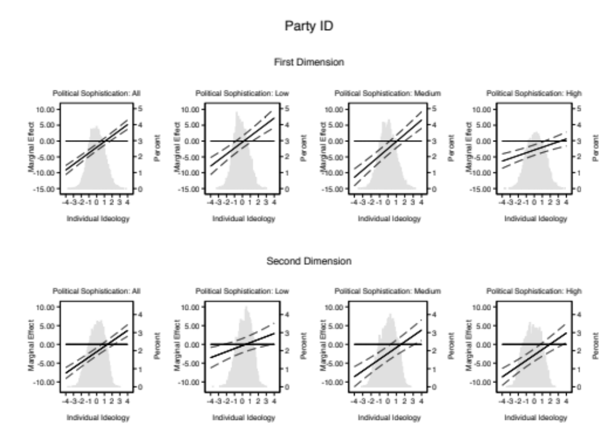

Table A8
Ideology and Voter Sophistication
 | All | Low | Medium | High
 | (1) | (2) | (3) | (4)
Congressional Polarization | -1.948*** | -0.0709 | -1.547** | -2.664***
 | (0.421) | (1.318) | (0.665) | (0.582)
Mean Congressional Ideology | 1.939*** | -0.264 | 2.258** | 2.155**
 | (0.617) | (1.856) | (0.988) | (0.856)
Individual First Dimension | 0.108 | -0.0716 | -0.140 | 0.337***
 | (0.0830) | (0.339) | (0.137) | (0.106)
Individual Second Dimension | -0.126 | 0.161 | -0.00447 | -0.0904
 | (0.0837) | (0.312) | (0.134) | (0.114)
First Dimension * Congressional Polarization | 0.627*** | 0.231 | 0.726*** | 0.518***
 | (0.114) | (0.486) | (0.188) | (0.146)
Second Dimension * Congressional Polarization | 0.803*** | 0.0361 | 0.595*** | 0.783***
 | (0.116) | (0.445) | (0.185) | (0.157)
Education | 0.0602*** | 0.00532 | 0.0485** | 0.0807***
 | (0.0135) | (0.0527) | (0.0220) | (0.0182)
Family Income | 0.0103 | -0.0222 | -0.00216 | 0.0332***
 | (0.00943) | (0.0316) | (0.0150) | (0.0128)
South | 0.0474* | 0.135 | 0.0599 | 0.00123
 | (0.0261) | (0.0833) | (0.0417) | (0.0352)
Non-White | -0.0625* | 0.144 | -0.0280 | -0.204***
 | (0.0327) | (0.0987) | (0.0502) | (0.0458)
Democratic Vote Share | 0.898*** | 0.312 | 0.850 | 0.873*
 | (0.330) | (1.001) | (0.531) | (0.450)
Constant | 5.015*** | 4.100*** | 4.816*** | 5.415***
 | (0.238) | (0.734) | (0.370) | (0.336)
Observations | 11177 | 1039 | 4499 | 5639
R-Squared | 0.292 | 0.0325 | 0.172 | 0.444
Robust standard errors in parentheses: * p<.10 ** p<.05 *** p<.01

Figure A2
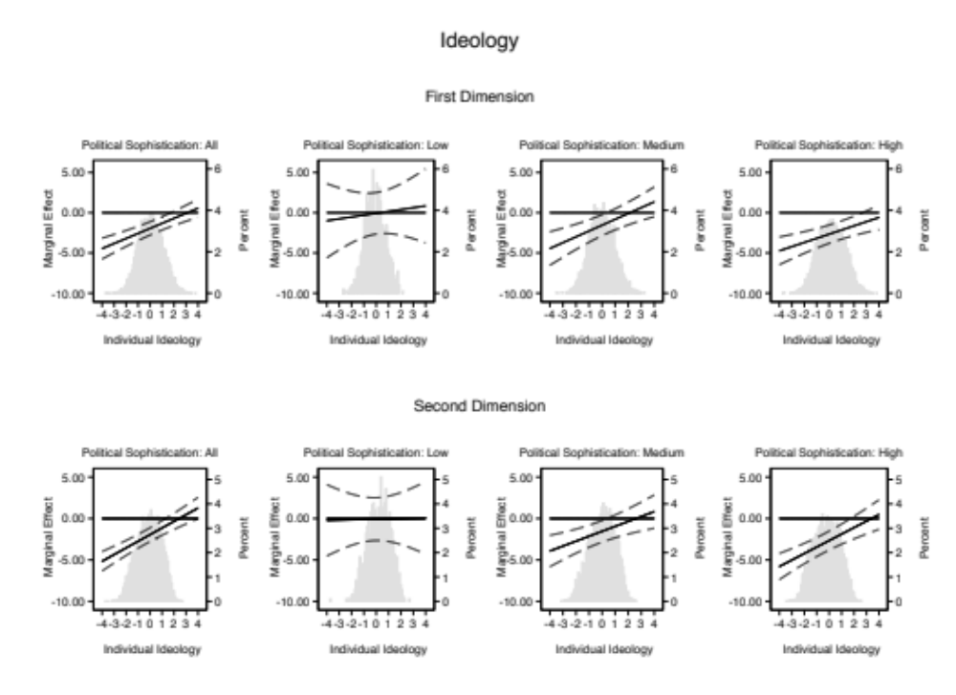

Table A9
Vote Choice and Voter Sophistication
 | All | Low | Medium | High
 | (1) | (2) | (3) | (4)
Congressional Polarization | 1.768*** | -0.752 | 2.772*** | 1.627*
 | (0.567) | (1.241) | (0.939) | (0.931)
Mean Congressional Ideology | -0.974 | 1.188 | -2.990** | 0.712
 | (0.831) | (1.834) | (1.384) | (1.343)
Individual First Dimension | 0.637*** | 0.566** | 0.834*** | 0.539***
 | (0.121) | (0.240) | (0.197) | (0.209)
Individual Second Dimension | 0.632*** | 0.366 | 0.593*** | 0.807***
 | (0.104) | (0.224) | (0.173) | (0.175)
First Dimension * Congressional Polarization | -1.892*** | -1.401*** | -1.961*** | -2.071***
 | (0.173) | (0.340) | (0.277) | (0.304)
Second Dimension * Congressional Polarization | -1.387*** | -0.727** | -1.286*** | -1.799***
 | (0.147) | (0.316) | (0.243) | (0.251)
Education | -0.164*** | -0.112*** | -0.176*** | -0.128***
 | (0.0170) | (0.0408) | (0.0284) | (0.0267)
Family Income | -0.0632*** | -0.00353 | -0.0447** | -0.0967***
 | (0.0118) | (0.0257) | (0.0195) | (0.0190)
South | -0.0634* | -0.0846 | -0.0265 | -0.121**
 | (0.0331) | (0.0682) | (0.0542) | (0.0554)
Non-White | 0.727*** | 0.938*** | 0.709*** | 0.623***
 | (0.0411) | (0.0819) | (0.0673) | (0.0692)
Democratic Vote Share | 3.211*** | 5.861*** | 2.779*** | 2.479***
 | (0.439) | (0.998) | (0.738) | (0.690)
Constant | -2.216*** | -1.900*** | -2.813*** | -1.740***
 | (0.303) | (0.636) | (0.499) | (0.500)
Observations | 10732 | 2297 | 3545 | 4890
Log-Likelihood | -5093.1 | -1140.4 | -1845.9 | -1966.2
Robust standard errors in parentheses: * p<.10 ** p<.05 *** p<.01

Figure A3
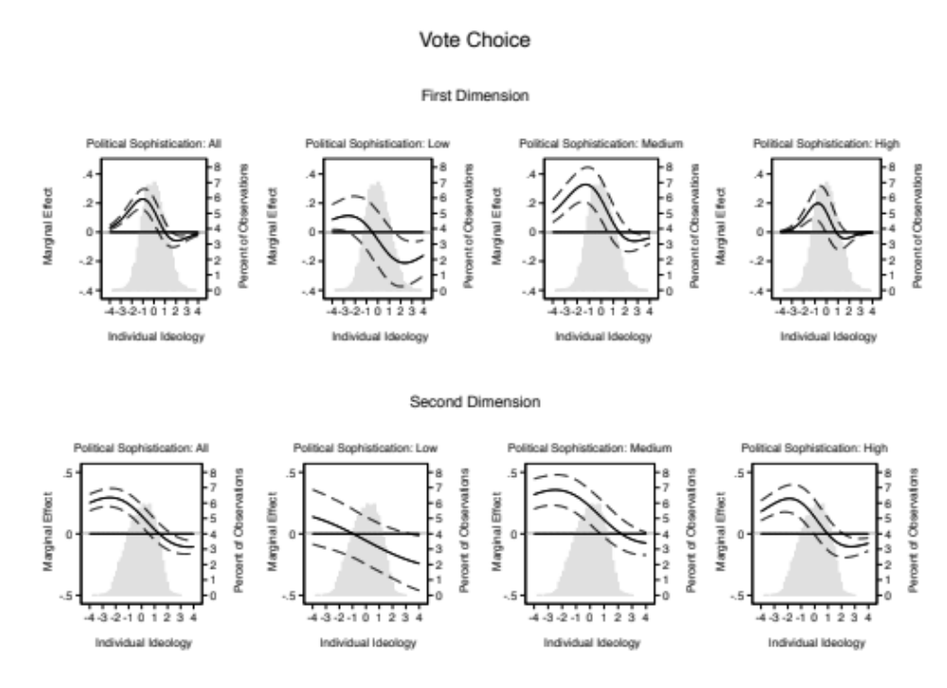

Table A10
Affect Polarization and Voter Sophistication
 | All | Low | Medium | High
 | (1) | (2) | (3) | (4)
Congressional Polarization | 122.0*** | 97.26*** | 110.8*** | 139.4***
 | (11.42) | (21.40) | (19.82) | (18.15)
Mean Congressional Ideology | -133.9*** | -101.6*** | -131.5*** | -151.6***
 | (17.80) | (33.23) | (31.04) | (27.85)
Individual First Dimension | 9.507*** | 25.54*** | 18.97*** | -4.780
 | (2.476) | (5.679) | (4.344) | (3.670)
Individual Second Dimension | 7.305*** | 5.656 | 20.14*** | 5.028
 | (2.524) | (5.537) | (4.564) | (3.841)
First Dimension * Congressional Polarization | -36.62*** | -46.90*** | -46.01*** | -22.85***
 | (3.303) | (7.665) | (5.795) | (4.940)
Second Dimension * Congressional Polarization | -19.18*** | -9.954 | -34.81*** | -19.75***
 | (3.378) | (7.345) | (6.075) | (5.217)
Education | -2.222*** | -0.668 | -2.995*** | -1.668***
 | (0.368) | (0.793) | (0.626) | (0.585)
Family Income | -1.113*** | -0.330 | -0.926** | -1.607***
 | (0.251) | (0.486) | (0.425) | (0.391)
South | -1.290* | 0.111 | -1.646 | -2.175*
 | (0.682) | (1.261) | (1.146) | (1.114)
Non-White | 12.91*** | 14.68*** | 13.36*** | 12.41***
 | (0.783) | (1.358) | (1.342) | (1.345)
Democratic Vote Share | -12.34 | 19.59 | -23.58 | -21.74
 | (8.978) | (17.19) | (15.82) | (13.66)
Constant | -71.63*** | -73.43*** | -55.72*** | -80.84***
 | (7.597) | (14.39) | (13.06) | (12.06)
Observations | 12557 | 3518 | 4235 | 4804
R-Squared | 0.320 | 0.166 | 0.259 | 0.458
Robust standard errors in parentheses: * p<.10 ** p<.05 *** p<.01

Figure A4
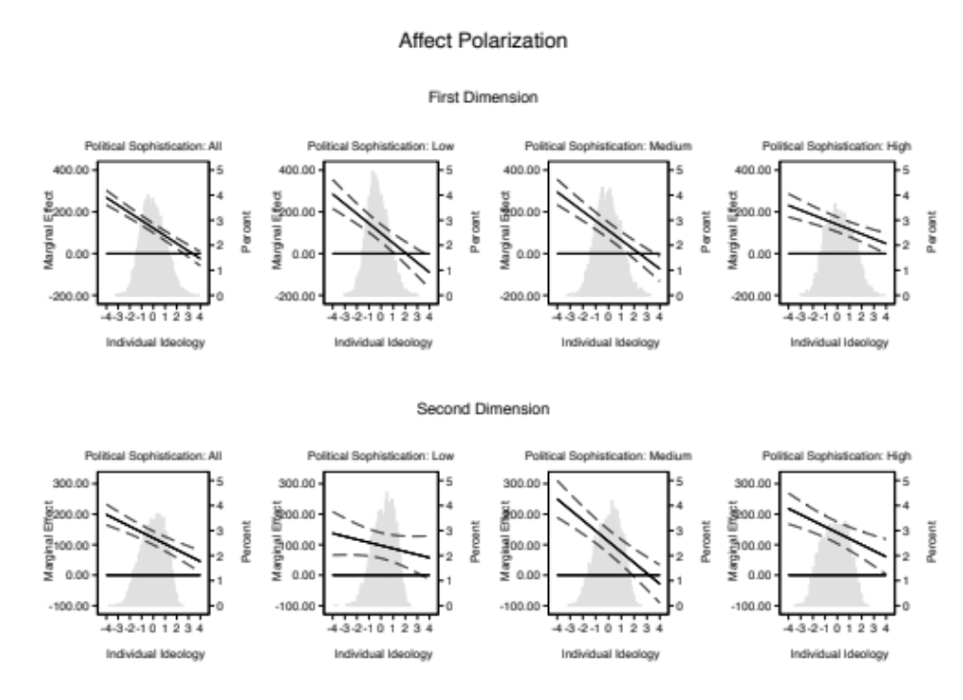

Table A11
Polarization Change Models
 | Party ID | Ideology | Affect Polarization | Vote Choice
 | (1) | (2) | (3) | (4)
Δ Polarization | -4.069*** | -2.806*** | 150.5*** | 4.047***
 | (1.092) | (0.925) | (21.97) | (1.055)
Mean Congressional Ideology | 2.486** | 2.844*** | -163.1*** | -2.367**
 | (0.998) | (0.828) | (20.91) | (0.938)
Individual First Dimension | 0.637*** | 0.501*** | -14.49*** | -0.548***
 | (0.0226) | (0.0192) | (0.498) | (0.0272)
Individual Second Dimension | 0.211*** | 0.428*** | -6.390*** | -0.296***
 | (0.0238) | (0.0192) | (0.497) | (0.0235)
First Dimension * Δ Polarization | 3.991*** | 1.569*** | -95.28*** | -4.358***
 | (0.488) | (0.426) | (10.77) | (0.726)
Second Dimension * Δ Polarization | 1.754*** | 0.584 | -14.36 | -1.244**
 | (0.541) | (0.429) | (11.01) | (0.590)
Education | 0.222*** | 0.0651*** | -2.136*** | -0.174***
 | (0.0176) | (0.0135) | (0.370) | (0.0170)
Family Income | 0.0442*** | 0.0104 | -1.238*** | -0.0644***
 | (0.0121) | (0.00946) | (0.252) | (0.0117)
South | -0.131*** | 0.0455* | -1.424** | -0.0592*
 | (0.0323) | (0.0262) | (0.685) | (0.0328)
Non-White | -0.739*** | -0.0607* | 12.85*** | 0.713***
 | (0.0364) | (0.0326) | (0.787) | (0.0395)
Democratic Vote Share | 0.531 | 1.604*** | -57.95*** | 2.570***
 | (0.582) | (0.468) | (11.66) | (0.559)
Time Trend | -0.0149*** | -0.0191*** | 1.162*** | 0.0176***
 | (0.00474) | (0.00393) | (0.103) | (0.00459)
Constant | 32.79*** | 41.54*** | -2283.2*** | -35.86***
 | (9.262) | (7.687) | (202.8) | (8.965)
Observations | 15267 | 11177 | 12557 | 10732
R-Squared | 0.253 | 0.287 | 0.316 | NA
Log-Likelihood | NA | NA | NA | -5171.6
Robust standard errors in parentheses: * p<.10 ** p<.05 *** p<.01

Figure A5
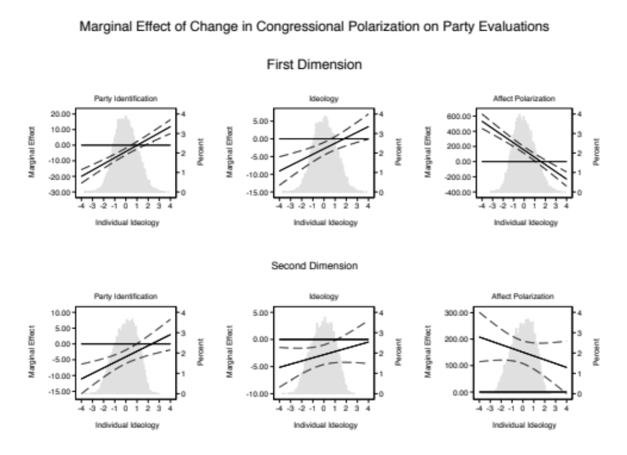
Figure A6
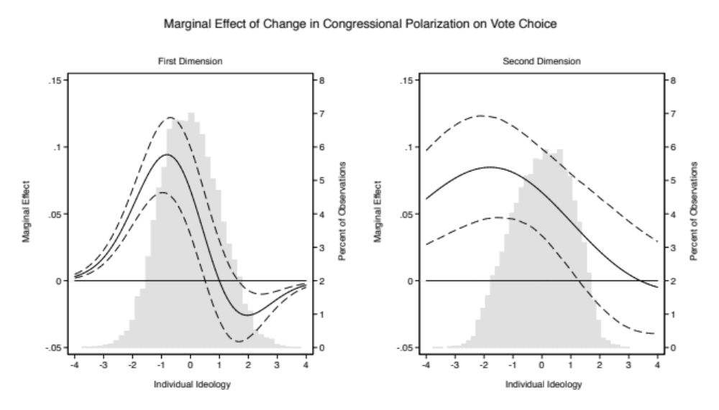

The exact wording of this question is as follows: “Some people feel the government in Washington should see to it that every person has a job and a good standard of living. Others think the government should just let each person get ahead on his own.”
We could easily rotate the matrix through a different question that loads highly on the first dimension. The choice is largely arbitrary. The important thing that this rotation achieves is that it rotates the factor matrix in the same way in each year, making the direct comparison of one year to another feasible because we are now using the same metric to evaluate changes.
The total numbers of questions that gauge an individual’s level of political sophistication vary from year to year. If unaccounted for, this year to year variation in the number available questions could pose problems for our additive sophistication measure, simply because respondents in years with more questions have more opportunities to answer questions correctly. In order to make our sophistication measure comparable across years, we transform our additive measure into the percentage of questions answered correctly.

